Internet Of Things Year 2 Assignment

Embedded Application Development

Name: Luke Halley
Course: Internet Of Things
Student Number: 20071820
Date: 29th November 2016
Submission Due Date: 2nd December 2016

Design (Using circuits.io):

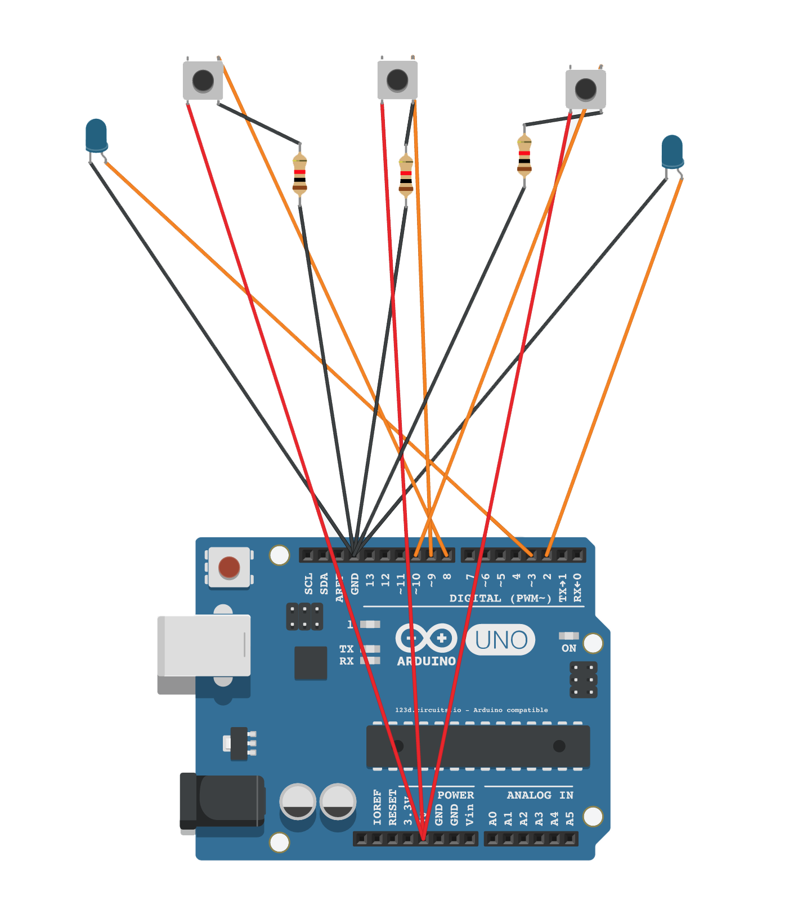
Components Used:
- Arduino Uno
- Three Buttons
- Two LEDS
- Connecting Wires
- Three Resistors

State Chart:



C Code:

int TIME_INTERVAL = 250; //0.5 Seconds

int HAZARD_IND = 0, LEFT_IND = 0, RIGHT_IND = 0, RIGHT_LED = 2, LEFT_LED = 3;

void setup()
{
pinMode(2, OUTPUT); //RIGHT LED
pinMode(3, OUTPUT); //LEFT LED

pinMode(8, INPUT); //LEFT INDICATOR
pinMode(9, INPUT); //HAZARD
pinMode(10, INPUT); //RIGHT INDICATOR
}

void loop()
{

HAZARD_IND = digitalRead(9);
LEFT_IND = digitalRead(8);
RIGHT_IND = digitalRead(10);

//Hazard Code

if (digitalRead(HAZARD_IND) == 0) {

digitalWrite(LEFT_LED, HIGH);
digitalWrite(RIGHT_LED, HIGH); // turn on both the LEDs

delay(TIME_INTERVAL); // wait one a second

digitalWrite(LEFT_LED, LOW);
digitalWrite(RIGHT_LED, LOW); // turn off both the LEDs

delay(TIME_INTERVAL); // wait for a second
}

//Left Indicator Code

if (digitalRead(LEFT_IND) == 0 && digitalRead(HAZARD_IND) != 0) {

digitalWrite(LEFT_LED, HIGH); // turn the LED on (HIGH is the voltage level)

delay(TIME_INTERVAL); // wait for a second

digitalWrite(LEFT_LED, LOW); // turn the LED off by making the voltage LOW

delay(TIME_INTERVAL); // wait for a second
}

//Right Indicator Code

if (digitalRead(RIGHT_IND) == 0 && digitalRead(HAZARD_IND) != 0) {

digitalWrite(RIGHT_LED, HIGH); // turn the LED on (HIGH is the voltage level)

delay(TIME_INTERVAL); // wait for a second

digitalWrite(RIGHT_LED, LOW); // turn the LED off by making the voltage LOW

delay(TIME_INTERVAL); // wait for a second
}

}

